LCD Touch Screen Phone
Design and Prototyping
_______________________

CSC 318: The Design of Interactive
Computational Media

Prepared For
_________________________

TA: Tira Cohene
Instructor: Ronald Baecker
Date: November 12, 2003

Presented by
_________________________

Branko Bulatovic (991663197)
Carlo Julian (990869066)
Cassandra Thian (990983539)
Michelle Li (991015931)
Tony Wu (991593637)

Table of Contents
1 Executive Summary 5
1.1 Conceptual Design 5
1.2 Functionality 5
1.3 Scenarios 5
1.4 Initial Usability Review 5
1.5 Usability Review Analysis and Implications 5
1.6 Interaction Design 6
1.7 Prototypes 6
1.8 Team Responsibility 6
2 Conceptual Design 7
2.1 Results from Requirements Analysis 7
2.1.1 Functional Requirements 7
2.1.2 Technical Requirements 8
2.1.3 Environment Requirements 9
2.1.4 User Requirements 9
2.1.5 Usability Requirements 11
2.2 Stakeholder Needs 11
2.2.1 Seniors 11
2.2.2 Family Members and Friends 12
2.2.3 Caregivers 12
2.3 Metaphor 12
2.4 Interaction Style 15
2.4.1 Interaction Modes 15
Instructing 16
2.4.2 Interaction Paradigm 17
2.5 Appearance 17
2.6 Behaviour 18
3 Functionality 19
3.1 Telephone 19
3.2 Flat Touch Screen 20
3.3 Emergency Button 20
3.4 Answering Machine 20
3.5 Caller ID 20
3.6 Personal Phone Book 21
3.7 Local Phone Directory 21
3.8 Personal Date Book 21
3.9 Speed Dial 22
3.10 Speakers 22
3.11 Video Camera 22
3.12 Notepad 22
4 Scenarios 23
4.1 Scenario 1: Answering Machine 23
4.2 Scenario 2: Video Conferencing 24
5 Initial Usability Review 25
5.1 Interview Methodology 25
5.2 Senior Reactions to LCD Touch Screen Phone 26
5.3 Non-Senior Reactions to LCD Touch Screen Phone 29
6 Usability Review Analysis and Implications 31
6.1 Physical Design 31
6.2 Interface Evaluation 32
6.3 Functional Evaluation 32
6.4 Miscellaneous 33
7 Interaction Design 33
7.1 Interaction Sequence 1: Listening to Saved Incoming Messages 33
7.2 Interaction Sequence 2: Making an Outgoing Call (Using Contact List) 34
8 Prototypes 35
8.1 Prototype 1: LCD Touch Screen Phone Program 36
8.1.1 Functionality 36
8.1.2 Look and Feel 36
8.1.3 Quality 37
8.1.4 Design Rationale 37
8.2 Prototype 2: LCD Touch Screen Phone Physical Model 38
8.2.1 Functionality 38
8.2.2 Look and Feel 38
8.2.3 Quality 39
8.2.4 Design Rationale 39
Appendix A: Scenario Sketches 42
Appendix A-1: Scenario 1 42
Appendix A-2: Scenario 2 44
Appendix B: System Flowchart 45
Appendix C: Interaction Sequence Diagrams 46
Appendix C-1: Interaction Sequence 1 46
Appendix C-2: Interaction Sequence 2 47
Appendix D: Prototype Design 49
Appendix D-1: Prototype 1 49
Appendix D-2: Prototype 2 50

Executive Summary

This documents report the results of the design and prototyping stages for the LCD Touch Screen Phone.

Conceptual Design

Here we describe the problems that we intend to address with our envisioned system. We also discuss the needs of our various stakeholders, and the related requirements that results from our Requirements Analysis. Also in this section, we employ various metaphors through which users come to understand our design and the interaction style from which they will engage in.

Functionality

We outline the LCD Touch Screen Phone’s core set of functions and features.

Scenarios

We describe and illustrate key tasks to be performed in operating the new proposed system. These scenarios outline the positive aspects of the new system with respect to its use in the daily life of a stakeholder.

Initial Usability Review

We review the results of interviews that we conducted from two intended users, senior interviews A and B, as well as two potential stakeholders, non-senior interviews A and B.

Usability Review Analysis and Implications
A report summary of the various changes that were made as suggest from the feedback from interviews in Part 5, which helped refine our design.

Interaction Design

Key interaction sequences are detailed step-by-step by following through screen flows and interaction design layout.

Prototypes

Design decisions and challenges in producing a good design are discussed here. Two prototype models are presented as viable designs that are considered for the final system design.

Team Responsibility

Branko Bulatovic
- Functionality (initial)
- LCD Touch Screen Phone Program

Carlo Julian
- Interaction Design
- Prototypes and Diagrams
- LCD Touch Screen Phone Physical Model

Cassandra Thian
- Executive Summary
- Conceptual Design (including Metaphors)
- Initial Usability Review: Interview Methodology & Senior Interviews
- Usability Review Analysis and Implications

Michelle Li
- Executive Summary
- Conceptual Design: Metaphors & Interactive Paradigm
- Scenarios & Sketches
- Editing & Proofreading

Tony Wu
- Conceptual Design (initial)
- Functionality (final)
- Initial Usability Review: Interview Methodology & Non-Senior Interviews
- Usability Review Analysis and Implications
It should be noted that all team members took part in coming up with the design of the system as well as its look and feel.

Conceptual Design

Being able to communicate with others is a basic necessity of life. It is not surprising then, that much technology has been developed to enhance our ability to communicate with one another. Our goal is to design a communication device that retains and improves upon the functionality of modern phones and answering machines, while making them much more usable and addresses some of the physical limitations of senior citizens.
The telephone and answering machine are two devices that have become a regular part of the lives of many individuals around the world, but have become increasingly more complex as its functionality has grown throughout the years. To illustrate this complexity, consider that it is not uncommon for modern phones to have more than 30 buttons, including over 10 speed-dial buttons, a hold button, a mute button, a button for answering call-waiting, and much more. For many senior citizens, as well as many other people, this complexity can be overwhelming. Add to that the other common deficiencies in modern phones and answering machines (low volume, poor reception, etc.), as well as common limitations suffered by many senior citizens (poor hearing, poor vision, memory deficiencies, less accurate motor control, etc) and it is easy to see how these devices can become very unusable. Thus our proposed system shall address the aforementioned deficiencies of both the modern phone and the aging senior. The LCD Touch Screen Phone will make the phone and answering machine easy to use for seniors with diminishing capabilities.

Results from Requirements Analysis

Functional Requirements

The basic functionality of this phone will still be based around the modern telephone. The ability to send and receive a telephone call is mandatory. The second major function of the phone system is to incorporate an answering machine. The user must be able to check and delete messages, as well as record outgoing messages. The ability to remotely check messages will also be available, much like many current answering machines. Many seniors indicated that they would like to be able to see the person to whom they are speaking. This can be implemented by having a mounted camera on both ends. Some seniors have hearing problems and have trouble hearing the phone ring. This can be addressed by having a flashing signal whenever the phone is ringing.
The phone will also incorporate a personal contacts phone book, in which contact information can be stored and retrieved. This would include an optional picture of the person. However, it would be tedious if the user had to search the phone book each time, especially for people they call frequently. Thus, a built in function would display a list of the most frequently dialed numbers, which would be made available to call quickly and conveniently. This functions much like the speed dial function on many phones. Along these lines, a date book will also be included, since many of our target users schedule plans and exchange information over the phone.
Some seniors indicated the need to write things down while talking on the phone, thus we plan to incorporate a “notepad” type of feature, where the user can write things down using an electronic pen. This notepad would also be able to record sketches to sketch things such as maps. We will also include an emergency button that is easily accessible and would connect a call to an emergency contact. Finally, an electronic telephone directory like the yellow pages will be included.

Technical Requirements

Basic technical requirements for the LCD Touch Screen Phone will not deviate far from that of a regular telephone. A phone jack will be required to connect to the phone, as well as a power jack to connect power. An internet connection will also be required for the telephone directory, to keep it updated. This will be made available through a network port on our phone. In addition to these basic requirements, we must also consider sophisticated technological requirements.
The proposed phone system will make use of a large LCD touch monitor, capable of displaying high-quality, full colour video in real time, while at the same time, displaying touch sensitive buttons on the screen. This operates very much like the touch screens of the “automated box office” booths found at movie theatres. In order for users to have face to face interaction through the system, a small mounted camera much like today’s web cam will be built into the phone system. This allows the user to see the person on the other end, assuming that the other person is also using the same system.
There is no receiver meaning that the user does not have to hold it to his or her ear, and that the phone is never left off the hook. However, there may be a remote receiver that can be used when the user is away from the phone base. To keep things simplified, the remote receiver will only have a button to talk and hang up. The result is an extremely easy-to-use cordless handset. Ringer and receiver volumes will be made adjustable based upon user’s comfort level.

Environment Requirements

The environmental requirements for the LCD Touch Screen Phone are minimal. It will be wall mounted or placed on a table top somewhere in the home. Lighting is not a dictating issue for choosing a location as the LCD screen will be backlit making it easy to read even in dim light. Phone calls may be conducted under a range of noise levels, from low noise level to moderate-to-high noise level. In an environment with little or no noise, the speaker on the other end may be easily heard.

User Requirements

The target users for the proposed system are senior citizens (although non-seniors will be able to make full use of our phone). By addressing health issues involving certain seniors, seniors who in the past were unable to properly use a telephone due to ailments will now be able to use a phone system with ease and comfort. The user must still possess sufficient vision in order to view the screen and follow the interface. Otherwise, the user would need someone else to assist in the operation of the phone. The user must also posses enough manual dexterity in order to press buttons on screen; these buttons will be made large enough requiring little precision. The notepad feature will also require a certain amount of manual dexterity, about as much as would be required to write with a normal pen and paper.
The interface must be intuitive and as easy to use as possible. The large LCD touch screen will be the basis for this philosophy. Big buttons with large, readable text will be used. The text must be descriptive and informative yet concise. For example, if new messages have been recorded on the answering machine, a button would appear saying, “Press here to check your messages”. Some indication must be given to the user that the have pushed a button, such as a beep (or similar noise), or some sort of animation or change of colour of the button pressed. We should have things organized in a system of menus and submenus, but careful not to allow submenus to run too deep. If the submenus run too deep, users may become lost and confused. We should also include a “return to top” type of button that is available on every submenu.
As for being context sensitive, our phone will display on its screen only the buttons for options that are currently available. This will keep things simple for the user. For example, only when one is already speaking to someone and receives an incoming call will one be presented with a button which reads, “You have an incoming call. Press here to answer the incoming call.” Another button on the screen will be available for the user to press in order to return to the previous call.
We want our address book to be easily searchable. The user should be able to search alphabetically. Also, a photo will be displayed during conversations with that particular person. This will help remind the senior with whom they are speaking— this is especially helpful to seniors with memory problems.
Finally, we want to have a simple, intuitive control for changing the volume. Some current phones use clumsy knobs that make it hard to tell where the volume is set at. Our phone will have a control on screen whenever necessary (talking to someone, listening to messages) to change the volume. This can be done with simple up/down buttons, along with a meter that displays the current volume level.

Usability Requirements

In order for the LCD Touch Screen Phone to be effective towards the needs of the seniors it must be easy to use and similar to a standard phone in order for seniors to which to easily relate, thus allowing them to successfully carry out system tasks. Having only the required options available to the user allows the senior to perform their desired task through a minimal number of steps by a simple touch of an option button. The outcome is not only operation efficiency, but a lower learning curve as well.
The emergency button is intended as a safety feature that is to be only selected in the case of emergency. In order to prevent the user from mistakenly activating the emergency button, this option will not be located near any main functions buttons such as the number pad.
Descriptive menu options with colour coordination further the simplicity of the design, allowing the senior to remember how to perform their desired task through grouping and familiarity. Also in order to help seniors remember where to find a particular option, menu options should be categorically structured, in which related functions are closely linked or positioned.

Stakeholder Needs

Seniors

The seniors are the main stakeholders of our device. They have social needs that need to be fulfilled through communication with other people. Moreover, physical and mental ailments that some seniors experience are a reality with which they must deal on a daily basis, where even simple tasks may be difficult to accomplish. These seniors require a system designed to help alleviate them of the problems that aging may incur. As a result, the system will require a large bright screen, loud ring tones, large font, and easy-to-press buttons. .

Family Members and Friends

These are the people in closest contact with the seniors. It is important for them to be able to keep in touch with the seniors. Friends and family members need to know that the senior is safe and that they can be contacted in case of emergency. Hence there will be an emergency contact button installed on the physical device. In order to enable seniors to contact and be contacted by their family and friends they need a device which will allow communication in a reliable and straightforward manner. Including a video camera permits both parties to see each other in person.

Caregivers

The caregivers don’t have any major needs with respect to the device. Indirectly however, being able to operate a phone easily and be in social contact with others will have a positive impact on a senior’s health, which is the main concern of a caregiver. Also, caregivers may need to contact a senior while they are away, and it would be best if the senior didn’t have any trouble operating the phone. An address book (also known as the contacts list) aids seniors in dialing familiar numbers, reducing senior reliance on the caregiver. The usability requirements address the need for the device to be fairly comprehensible and simple to use, in order to allow universal usage and more importantly senior application.

Metaphor

The LCD Touch Screen Phone is to be developed to be similar in some ways to existing concepts and designs familiar to our users. The intention is to enable the users to understand and in turn, use the functionality provided by our phone to their advantage. Field studies indicated that the ATM level complexity is acceptable for the seniors to operate, thus we have designed our LCD Touch Screen Phone to have an interface that is similar, in certain respects, to that of an ATM. Menus are kept context sensitive with minimal number of options on display at any given time. In order to ease the transition to the new phone, our design is similar to an ordinary phone, such that the system’s base functionality is still that of a telephone. The user needs to be able to map functions of a regular phone onto the LCD Touch Screen Phone. Below is a list of metaphors that have been devised:

Application Area | Metaphor Used | Similarities | Differences
Operating LCD Touch Screen Phone | Using a phone and answering machine | - Speed dial, call waiting, call display, and other options of a standard phone are all available on the LCD touch screen phone.  - Keying in a telephone number and performing standard operations, such as making a call and answering a call.  - Available option of a portable receiver, which allows users to move around freely.  - Message retrieval and playback. | - The large keypad buttons are on the LCD monitor, which will not suffer the wear and tear of normal telephone keypads.  - Only relevant and needed options are present on the LCD screen at any given time, as opposed to the standard phone that has all buttons present at all times.  - Available options are color coded and are always placed in the same position when visible on screen in order to keep familiarity with user.  - Wide range of ringer volumes as well as speaker volumes, and are adjustable to suit the users preference.  - LCD Touch Screen Phone is equipped with extra features, such as video conferencing, a built in phone directory and an interactive notepad.  - A separate ‘keyboard’ is built into the phone so as to avoid the confusion of having multiple alphabets letters on a single button, as in regular phones. The keyboard is invoked only when text entry is necessary and displayed at bottom of screen.
Menu Navigation | Using an ATM | - Buttons perform a given action when pressed.  - Pressing a button results in a visible change on screen.  - Limited selections at any given time.  - Branching options  - Traceable path through options. | - Screen on the LCD Touch Screen Phone is divided into three distinct panels.  - The LCD Touch Screen Phone is more visually appealing with a brighter appearance including color coded buttons that allow users to understand the display and available options.  - ATM requires user to retain information mentally (e.g. PIN), whereas information is stored and easily retrieved on the LCD Touch Screen Phone (e.g. contacts list).
Built in Phone Directory with Yellow Pages | Phone directory | - Contains the same information  - Information ordered in the same manner.  - Allows user to search through list of phone numbers in the same manner as a standard phone directory | - Search options available to narrow searches such as City or Last Name.  - To suit the needs of seniors with vision difficulties, text can be magnified to the user’s preference.
Writing on Notepad | Writing on memo pad | - Users can copy down handwritten information while conversing | - Pen tool acts as both a writing utensil and eraser.  - Notepad pages can be saved electronically.
Text Information Input | Keyboard | - Each key represents a letter of the alphabet  - Used to type in text | - Keys on device do not follow QWERTY ordering system, but are arranged in alphabetical. order.
Contacts | Address Book | - Stores information about people like names, phone numbers, and addresses | - Picture associated with each contact.  - Contacts are stored in alphabetical order (new contacts are inserted in the proper order).  - Keyboard used for inputting information  - Automatic dialing from contacts section.
Date Book | Calendar and Personal Planner | - Used to keep track of dates, events, and appointments | - Daily and weekly views available detailing scheduled events.  - Audiovisual reminders before a scheduled event.
Table 2.3-1: System metaphors

Interaction Style

In order to determine the interaction style that the users of the LCD Touch Screen phone will engage in, it is important to take into consideration the needs and requirements of the user. Our field studies allowed us to gain first-hand knowledge of seniors, their capabilities, technological skills, and needs, which in turn, inspired ideas to help improve our design. This enabled us to have a well-defined perspective of the needs of seniors, allowing us to pioneer a functional yet eloquent system geared towards addressing issues confronted by our target user group. Seniors using the LCD Touch Screen Phone will engage in two types of interaction styles: interaction modes and interaction paradigms.

Interaction Modes

The interaction modes most suitable for the system are the ones based on activities. They depend on the activities that the users will engage in; the suitable interaction modes for our particular system are instructing, and manipulating and navigating.

Instructing

As an instruction-based conceptual model, the system will allow for quick and efficient interaction. The users will be selecting menu options available to them on the Main Menu screen. From this screen the user will be able to have access to the personal contacts list, date book, phone directory, and answering machine. A feature of the LCD Touch Screen Phone is to allow seniors to multitask, and enable them to issue instructions to the phone while performing different tasks. An example of this would be storing a phone number on the system and entering the lines of information while speaking on the phone. One would simply call on the “Contacts” option and enter the desired input accordingly on the keyboard. When the task is completed, the keyboard will automatically disappear from the user’s screen and reappear only when required, as to minimize confusion for the user as well reduce clutter on the screen. In preserving the physical action of button pressing to dial a number allows the users to relate to the experience of making a call on any ordinary phone. This permits the senior to feel comfortable using the new phone by connecting familiar experiences and helps them overcome their fear of the unfamiliar.
A result from understanding the user’s needs is the decision to eliminate the voice command system. Although it is very convenient and it is becoming increasingly popular among new technology users, voice command was not a priority for seniors. It would be an unnecessary feature that would only complicate and discourage usage for the seniors.

Manipulating and Navigating

The conceptual model of manipulating and navigating provides immediate feedback from user commands, which help users learn the functionality of the system quickly. It is not uncommon for many seniors to suffer from memory loss as age progresses, thus it would be inappropriate to have option buttons dynamically placed as users would be confused and constantly looking for the options. In order to accommodate the needs of seniors with memory loss, we made the strategic design decision to have the buttons that are not always present to appear in consistent positions when they are invoked, which help users remember where to call on the options over time. Users gain confidence and feel in control, to help overcome their fear of change and technology in the world. Having the user navigate the system by choosing options by pressing buttons allow our users to perform specific actions without having to formulate specific questions to the system.
As described in Section 2.3: Metaphors, users can navigate the LCD Touch Screen Phone in a similar way as they would when using an ATM. As most of the interviewed seniors have used an ATM machine and had no complaints in its performance and complexity, there should be little difficulty in using the phone. The may manipulate virtual objects such as phone books and the answering machine through selecting commands.

Interaction Paradigm

Ubiquitous Computing

The interaction paradigm for the system is ubiquitous computing. The system utilizes concepts of existing physical objects; they are integrated with new technology in order to extend the current functionality. Our proposed system sets to improve and transform the telephone and answering machine, while at the same time adding further functionality to an address book, date book, calendar, and phone directory. When a user interacts with this system the user can imagine himself or herself using a standard version of the physical object, but just in electronic form with extended functionality and increased efficiency. The fundamental idea behind this paradigm is that the system does not present itself to be new technology; it is merely taking the standard telephone and through technological means, simplifying and tailoring it to the needs of a senior.

Appearance

A major concern regarding seniors and new technology, for example web browsing, is seniors’ inexperience due to the intimidating impressions presented by many new technological devices from their complicated user interfaces. Thus in order to help seniors overcome their fear, it is important to keep visual aspects of a standard phone constant and preserve the navigational aspects of an ATM present. The layout is to be simple and concise, allowing only relevant options to be present at any given time. The LCD Touch Screen Phone is divided into three panels. One end of the screen is dedicated to the electronic notepad equipped with a pen-like medium. In the center lies the main navigation screen in which the main menus are present, which also provide the space for the video box required by the video conferencing feature. On the other end of the panel is the phone pad. Related options on the navigation screen will be colour related to allow users associate certain tasks with each other. A clever colour scheme of the buttons allows users to relate it to the action it performs, this allows users to remember and learn the basic functionality more rapidly. An example would be to have the ‘Make a Call’ button green coloured, this would allow the user to relate to the action of going on a green light.
A red emergency contact button is to be place off to the side of the LCD touch screen in order to minimize accidental activation. Speakers are embedded into the physical model of the phone along with a volume control slider beneath. The video camera is a small circular lens located near the top of the phone.

Behaviour

The LCD Touch Screen Phone is designed and developed using a user-centered approach. Our goal is to take an important object that seniors need and rely upon and improve on it to suit their needs. Taking this into consideration, it is important to maintain all the functionalities that a standard phone possesses, and not only improve the functions that are already available, but pioneering functions that would cater to the senior’s needs. The phone would alert the user that there is an incoming call as would any standard phone with a ringing noise, which is adjustable to the user’s preference. To further indicate the incoming call or new message on the answering machine, the user is alerted by the flashing ‘Answer Call’ or ‘Receive Messages’ option buttons in order to catch their attention should the ringer be adjusted to a low volume. The metaphor used to describe the notepad is the action of writing on a memo pad. As in reality, should the user make a mistake, he or she must simply erase the error or use a fresh new sheet of paper. Keeping our design to behave as close to reality as possible allows the users to relate their daily experiences to the system, enabling them to familiarize themselves with the available functionalities more quickly. Options of deleting a page and requesting more pages are available only on the notepad portion of the LCD screen. The keyboard and number pad functions and behaves as any standard keyboard or number pad, whose main functions are to enter text and numbers into the system. Lastly, the answering machine behaves as any standard machine, notifying the user of received messages, storing, deleting, and browsing messages. The options of what to do with the messages are available to the user only when the answering machine is in use. These are displayed on large descriptive buttons, making it clear and simple for the user to decide what action to take next.

Functionality

Telephone

The main function of the system is to act as a telephone. The device is connected to a regular phone line and power jack, and will also be connected to the internet in order to update the phone directory database. Outgoing calls can be made whenever desired, and the phone rings upon receiving an incoming call. Along with the usual audio tone, a flashing signal is shown that notifies the user that there is an incoming call. The user converses by either standing or sitting in front or near the screen and speaks and listens to the speaker. The phone should always be able to receive calls, even when the phone is in use. In the event that the user is currently using one of the other functions and there is an incoming, a button is displayed notifying the user of the call. If the user accepts the call, he or she will still be able to do what he or she was doing before the call. Should the user receive another call during an ongoing call, a button will pop up saying “Incoming Call Waiting”. Te user may choose whether or not to take the call. The first call will be put on hold and the user will be able to toggle between calls by simple touches of buttons.

Flat Touch Screen
The prevalent feature of our phone is the backlit LCD touch screen with large easy-to- see buttons and large font for all the features. The screen allows the person to easily dial a number by touching the phone pad buttons on the screen. All other features will be available through the touch screen interface. Whenever buttons are pressed, the user will receive immediate feedback, such as colour change in the buttons and sound to indicated that the button as indeed been selected.

Emergency Button

The emergency button will be located off to the side of the LCD screen.. It will be large, red, and push activated. The button will be used by seniors to easily call for help since the button will automatically dial an emergency number (for example: 911) for the senior. Using this button requires low cognition, that is, since it is not on the screen, the user does not need to read text or navigate screens in times of high stress (or high cognitive load). The red button thus lends itself to be easily accessible and activated during emergencies.

Answering Machine
A built in answering machine will save audio or audiovisual messages for the senior. The outgoing message can be changed by selecting the “Record new outgoing message” option after going into the Answering Machine submenu. After a voice message is recorded, a message is displayed on the screen that lets the senior know that he or she has a message. Several options will be provided which allow the senior to play, replay, save or delete the message through simple and intuitive graphical buttons.

Caller ID
Whenever someone calls, the caller id in the form of a number and a name will be displayed on the screen in large letters. If the senior misses any phone calls they will be stored in a log of missed phone calls along with the time and the name of the person calling.

Personal Phone Book

The phone book will provide the senior with an easy way to store names, numbers, and additional information such as a photo and/or text notes. Contacts are to be stored in alphabetical order. A new contact is added by selecting the “Add New Contact” option while in the Contacts menu. Also, the user is always prompted if they want to save a number that they have dialed, and that is not currently in the Contact List. The phone book provides an easy way to add new numbers and to dial ones already in the database. Features will include add new number, delete number and find.

Local Phone Directory

The local phone directory allows the user to access the Yellow Pages without resorting to searching for numbers using a physical phone directory. Users may easily browse through pages by simple touches of a button, as well as perform searches for a specific business. The directory database is updated via the internet.

Personal Date Book

The date book allows the user to schedule events, meetings, or appointments. A calendar is displayed on the screen and selecting a particular day brings up the agenda for that day complete with planned activities entered by the user. There can also be weekly views of the user’s schedule. The user may schedule new events, modify events and times, or delete events. Fifteen minutes before a scheduled event will signal an audiovisual reminder to the user. The audio signal will be different from the phone’s ring tone, while the flashing of the phone will be a different colour and pattern from that which indicates an incoming call or new incoming messages.

Speed Dial

Speed dial will allow the senior to store around 10 numbers that are considered the most frequently dialed. These numbers will be displayed on the Main Menu so that the user can phone a someone with just one press of a button, saving him or her the trouble of searching through the contacts list.

Speakers

Speakers will be attached to the side of the screen. The volume will be easily adjustable via the screen 'volume control' button. This control is always available and displays the current level of volume, and is only adjustable manually to avoid confusion.

Video Camera

A video camera will be attached on top the screen to allow for audiovisual conversations. The camera will record the senior's face if the audiovisual option is chosen when making a call.

Notepad

A portion of the screen will be dedicated to be a notepad with an electronic pen attached with which to make any notes during a conversation. This is always available so that the user can make notes whenever necessary. The writing device may be used as a pen or an eraser depending on which pen tool is chosen.

Scenarios

The following scenarios speculate how the envisioned system will operate in the daily life of a primary stakeholder.

Scenario 1: Answering Machine

Gertrude Longbottom – 72 year old woman who lives alone in an apartment. Her memory and hearing is not what it used to be. She has a fulfilling social life, which involves getting together with fellow tenants and friends as well as enjoying the occasional game of bridge.

Gertrude Longbottom is a 72 year old woman who is currently taking a shower. During the shower, her LCD Touch Screen Phone rings. The answering machine picks up and a message is recorded from the caller. After her shower, Gertrude walks past the family room and sees the phone screen flashing in red, indicating that there are new messages. The phone screen displays “You have 1 new message”. She touches the “Receive Messages” button to enter the Incoming Messages screen that displays a list of all new messages, including the date, time, and phone number from which the call was made. She chooses to listen to message #1, left just 10 minutes ago. The message is from her friend Beatrice, who wants to know whether she will be going a bridge game hosted by Beatrice’s friend Agnes Potter. After the message finishes playing, Gertrude decides to phone Beatrice back by touching the button “Call Back”. The system automatically dials the number and Beatrice picks up. Gertrude informs Beatrice that she would be delighted to join the bridge game and would like to know directions to Agnes’ place. Beatrice is not very good at directions, so she suggests that Gertrude phone up Agnes to get all the details from her. She recites Agnes’ phone number and Gertrude records the number on the screen notepad. Upon finishing the conversation, Gertrude refers to Agnes’ phone number on the screen and dials the number on the large button phone pad located on another portion of the screen. She is immediately connected to Agnes, who then gives detailed directions to her house while Gertrude records the information on the notepad. Once Gertrude hangs up, she immediately navigates to her personal contacts directory and adds a new contact card; she types in the name Agnes Potter and her phone number and address using the keyboard that has popped up on screen. In the Additional Information section, she adds the directions to get to the address. After Gertrude saves the new information, Agnes’ contact is filed in alphabetical order among the rest of Beatrice’s contacts. Please refer to Appendix A: Scenario 1 Sketches.

Scenario 2: Video Conferencing

Walter Sainsbury is an 88-year old man who lives in a house with his son, John, and daughter-in-law, Amy. He was once agile and fit but is now suffering from arthritis because of his age. Walter has also been having problems with his eyesight and he requires strong reading glasses in order to read small type.

Walter Sainsbury’s youngest granddaughter, Lily Smith is celebrating her 5th birthday today. Because Walter lives in a different city as the Smiths, he won’t be able to see visit Lily. However, both Walter and the Smith household own an LCD Touch Screen Phone so grandfather and granddaughter can be able to see each other on screen during a phone conversation. Walter slowly walks to his phone and easily navigates to the screen where all his contacts are stored. He finds the Smiths in his frequent contacts list on the Contacts creen, and with the simple press of a button on the screen, he activates automatic dialing. Walter’s daughter, Lisa, picks up the call and her image immediately appears on Walter’s screen. Balloons float in the background and Lily runs up to the screen. They have a wonderful chat and afterwards, Walter up with another press of the screen. All in all, Walter is satisfied about feeling included in Lily’s special birthday celebration. Please refer to Appendix B: Scenario 2 Sketches.

Initial Usability Review

Interview Methodology

We want to gather reactions from various individuals about our system concept and proposed functionality. We will accomplish this by using an unstructured interview process with open-ended questions. First, the overall concept is explained to the interviewee. The interviewee may then ask questions to clarify their understanding of the system. The interviewee is also presented with scenarios and sketches of the system and design. The interviewee is always free to ask any questions they may have at any time.
This is to ensure that they have a clear understanding of our system.
At this point, we ask for feedback from the interviewee regarding their overall impressions. We take note of the comments, both positive and negative. Afterwards, we explain each main feature of the phone and steps to carry out various tasks, after which we ask for feedback on each feature. The interview method is kept unstructured with open ended questions. Follow up questions are asked at our discretion to get detailed comments and to ensure that the designers and testers understand each other. In short, our process is informal, and involves open discussion about our proposed system. The discussion consists of explanation of our system, and then gathering feedback.
We will interview four people in total. Two will be seniors, which is obviously important since they are the intended user of the device. We would like to interview one senior who was interviewed in the original field study, and one who has not yet been interviewed. By doing this we get two different perspectives, both still being from the target users of our device. The other two interviewees will be non-seniors. These people will have seniors as friends or family members. This allows us to get relevant feedback from non-senior stakeholders. This is a good follow up to make sure that we have followed through properly on the requirements from the fields studies.

Senior Reactions to LCD Touch Screen Phone

Here we will introduce the seniors we interviewed. The first senior we interviewed (known as “Senior A”) is a 67-year-old retired male who has arthritis in his hands. The second senior we interviewed (known as “Senior B”) is a 63-year-old woman who has bad eyesight and failing memory. Both seniors expressed that they were comfortable with technology, where senior A was more experienced that senior B. Our main goal in interviewing the seniors was to determine whether or not they felt that our LCD Touch Screen Phone satisfied their needs. It was important to know if they felt that they could incorporate it into their daily lives and successfully replace their current phone.

Physical Design

In introducing our LCD Touch Screen Phone, we presented the idea that the size of main navigational portion of the LCD screen would be about 8.5” x 11”, the size of a standard sheet of paper, and asked both seniors to comment on whether they thought this was a suitable size. Senior B expressed that she was content with the size, and suggested that it should be as big as possible, which was not surprising considering her imperfect vision. Senior A, on the other hand, was unconcerned about the size of the screen as long as it was convenient. We also presented the idea of the emergency contact button. Both seniors felt that it was a good idea as it is a feature that would make them feel more at ease in their household.

Interface Evaluation

At this point in the interview, we presented our seniors with our interface sketches (please refer to Appendices A and B) as to get feedback on their opinions regarding the presentation of our LCD Touch Screen Phone. Both seniors suggested that buttons with certain features should be colour coded, however they were pleased with the distinct visibility of the keypad buttons due to their large size. Senior A brought up an interesting point when he expressed how he disliked the dual function of letters and numbers being on the same keypad as one would find on traditional phones. We further explained that the mission of our design was to keep context sensitive menus in which only needed options were available at any given time. Both seniors acknowledged the simplicity of the layout, which they felt was important as well as helpful. Senior B felt it was important that the main menu buttons were consistent in their placement when and if available at any given time, she explained that this was due to her occasional forgetfulness and need for familiarity.

Functional Evaluation

In order to help us limit the features of our phone down to the necessary and significant functions, we asked the seniors to look at the functionality that the LCD Touch Screen Phone offers and to give us their opinions as to whether each function would be useful to them. The following table summarizes the results (U=Useful, X=Not Useful):
Functions | Senior A | Senior B
Phone Book | U | U
Contacts | U | U
Speed Dial | U | U
Notepad | U | U
Date Book | U | U
Emergency Button | U | U
Caller ID | U | U
Camera | U | U
Answering Machine | U | U
Answering Machine Warnings
Audible | U | U
Visual (flashing screen/buttons) | X | U
Table 5.2-1: Functionality Table (Seniors)
After filling out the table, we asked each senior to comment briefly on the functions they liked and did not like and why they felt the way they did. Both seniors found standard functions on ordinary phones helpful and found no reason to discard them, thus functions such as speed dial, caller ID and storable contacts were favourable among both seniors. A well received innovative function was the phonebook, about which senior B was especially pleased, as there was an enlarging font option, which was important for her vision difficulty. Senior B felt the visual flashing buttons for incoming calls and notification of answering machine messages were unnecessary as she thought she would be unable to see it anyways, and felt the audible warning would be more appropriate. Although we took this comment into consideration, we felt it was important to keep the flashing buttons since it would end up being a greater good, which would also include those seniors who did not have poor vision, and would take notice of the warning without difficulty.

Overall Impression

On the whole, both seniors were impressed and attracted to the LCD Touch Screen Phone. Senior A felt confident that he would be comfortable with the design as he was more receptive to technology. Senior B liked that the functionalities that would cater to her physical needs, such as her ill-vision. They concluded that they could picture themselves making use of the phone and incorporating it into their daily activities. When asked if they could perhaps make any more suggestions, Senior B recommended an email option. This was somewhat expected as Senior B is experienced with new media tools, however as initially proposed, our purpose was to excel in fulfilling a concentrated need of seniors as oppose to undertaking many functionalities.

Activity Design Scenarios Reactions

Both seniors thought that the scenarios were fair depictions of the lives of seniors. They noted that obviously everyone is different and that preconceived notions can be generalized to the larger population. They agreed that activities such as keeping in touch with and getting together with friends and family are definitely an important part of seniors’ lives. Senior B was still somewhat skeptical of how easy it would be to learn to use new phone, saying that “They always make it sound so easy”. Overall, both felt that the system design did seem to simplify things and make things more organized.

Non-Senior Reactions to LCD Touch Screen Phone

We interviewed two people, who we will refer to as Person A and Person B. Person A is 22 year old female student, who speaks often with her grandfather on the telephone. Person B is a 39 year old male who frequently visits his parents.

Interface

Sketches and descriptions of the system design were given to the two interviewees. Both generally liked the interface design. The idea of keeping menus context sensitive was a very important point, since it is confusing to have many options available at a time. The interface was simple and intuitive. They liked the idea of having big buttons, and large and descriptive text. One question brought up by Person A was: "How will text be inputted"? She suggested a small button that toggles between a virtual keyboard and no virtual keyboard. Person B brought up a point about the emergency button, stating that it might be too easy to call the emergency contact by accident, causing much hassle.

Physical Design

Both people liked the basic design of the device, especially the large LCD monitor. The option to wall-mount or place on a table adds versatility. Person A was a little wary of the big emergency button being too visible for constant use because it can easily be pressed by accident. Otherwise, there were no issues with the physical design.

Functions

In order to help us limit the features of our phone down to the necessary and significant functions, we asked the non-seniors to look at the functionality that the LCD Touch Screen Phone offers and to give us their opinions as to whether each function would be useful to them. The following table summarizes the results (U=Useful, X=Not Useful):

Functions | Senior A | Senior B
Phone Book | U | U
Contacts | U | U
Speed Dial | U | X
Notepad | X | U
Date Book | U | U
Emergency Button | U | X
Caller ID | U | U
Camera | U | U
Answering Machine | U | U
Answering Machine Warnings
Audible | U | U
Visual (flashing screen/buttons) | X | U
Table 5.3-1: Functionality Table (non-seniors)

Person A thought that the electronic notepad would offer nothing over a regular pen and paper. She stressed that the contact list and phone book be easily searchable and organized. She also felt that a loud tone be played at a specified interval to notify users of new messages. Person B felt that the emergency button should just be cut out, simply because it would cause hassle and may be rarely be needed. He also felt that speed dial could be confusing to set up for seniors, and that having 10 speed dial buttons would clutter up the Main Menu screen.
Overall Impressions

Person A was skeptical at first, but ended up with a fairly good impression of the system. She felt that having a screen with descriptive texts could be very helpful for seniors, as opposed to a regular phone that doesn’t really give any sort of feedback. Another point that she brought up was the fact that a regular phone will work without power. Further, it would be very power consuming if the display was always on.
Person B also had a good impression of the system in general. However, he felt that there should be a help option to provide assistance if the user is ever confused. Also, video/animated tutorials were suggested.

Activity Design Scenarios Reactions

Both interviewees generally liked what they read in the scenarios. “It seems to make things easier for seniors and ties related functions together”, said Person A. After reading the scenario, she agreed that the notepad function would eliminate the possibility of any clutter of pieces of paper. She also commented that the second scenario illustrates a good benefit of the video option. On this note, Person B commented that it really doesn’t differ much from web cam technology. Also, person B noted that “Using all the functions won’t always be as easy as you make it sound”.

Usability Review Analysis and Implications

Physical Design

Seniors in general were happy with the size of the screen as it catered to their needs. The Non-seniors had some minor issues with the physical design. There were no major issues that required a specific change in specifications. The LCD Touch Screen Phone will be placeable on desktop or wall-mountable. The base needs to be secure and stable, and the screen needs to be angled at a suitable tilt in order to withstand pressure.

Interface Evaluation

The interface and layout needs to be colour coded and follow a consistent colour scheme. Buttons such as "call" will be green, whereas buttons such as "hang up" will be red. We need special focus on making the interface clean and not confusing. Ease of use has been stressed continuously, and we need to pay attention to detail. Taking into consideration Senior A and Person A's comments about text input, we have concluded to have a virtual keyboard that is always displayed whenever text input is required. At other times it will not be displayed when it is not required in order to maintain the simplicity of the layout. We have decided not to use the idea of toggling the keyboard because it may become confusing and it goes against our context sensitive scheme. We will need to relocate the emergency button so that it will not be pressed accidentally. The best place for this is to have it far away from the keypad. We are currently considering placing the emergency button in the bottom left corner (opposite the keypad).

Functional Evaluation

Overall, all the functions were deemed as being necessary, despite some disagreement. We did not feel that the disagreement was strong enough to justify major changes in the functions already included. We have decided to keep the notepad function as seniors have indicated that it would be a useful function. We disagree with the suggestion to have a loud tone notification when there are new messages in the answering machine, since it could become a nuisance to non-users and to the user if he/she does not want to check messages yet. We still feel that the emergency button is necessary, since it is an issue of safety. However we will make sure that it is placed properly so that it can be used when needed, but not pressed accidentally. Finally, instead of having 10 programmable speed dial buttons, our phone will have an automatic function which makes a list of the top 5 most frequently dialed numbers. This list is available whenever the user goes into the Contacts menu.

Miscellaneous

A good point brought up was that should there be a blackout, our phone would not function. This drove us to the solution that we should implement a back-up battery system, which is rechargeable.

Interaction Design

The following sequences describe key interaction sequences in using the LCD Touch Phone. Word’s in bold type font denote specific page names, while words in Italics denote specific buttons. In order to observe the prototype program in action, please run the included file named
318 Assignment 3 LCD Phone – Visual Basic EXE.exe.

Interaction Sequence 1: Listening to Saved Incoming Messages

The following interaction sequence will take place when the user wishes to listen to messages that have been saved on the LCD Touch Screen Phone. The diagrams referred to in this sequence are under Appendix C-1: Interaction Sequence 1.

- From the Main Menu, touch the Answering Machine button. (see Figure C-1.1)
- The Answering Machine Page appears, displaying a list of all saved messages. From here, you can choose to either listen to all currently saved messages (from most recent to least recent), or choose specific messages to listen to.
- If you wish to hear all messages, then, from the Answering Machine Page, touch the Play All Messages button. (see Figure C-1.2)
- The Message Playback Controls Page appears. After the time of its recording is announced, the most recent message will automatically begin playing. When the message ends, the time of recording for the next most recent message is announced, and the corresponding message is played. This continues until all messages have been played. At any time you may stop, pause or play the message, or skip to the previous or next message, using the Stop, Pause, Play, Previous or Next buttons, respectively. (see Figure C-1.3)
- If, instead of listening to all messages in sequence, you would rather choose a specific message to play, then, from the Answering Machine Page, browse the list of all saved messages and touch the button displaying the name (where known) or phone number (when name is unknown) corresponding to the message you’d like to hear.
- The Message Playback Controls Page appears. After the time of its recording is announced, the chosen message will automatically begin playing. At any time you may stop, pause or play the message using the Stop, Pause or Play buttons, respectively. (see Figure C-1.4)

Interaction Sequence 2: Making an Outgoing Call (Using Contact List)

The following interaction sequence will take place when the user wishes to make an outgoing call to someone on their Contact List. The diagrams referred to in this sequence are under Appendix C-2: Interaction Sequence 2.

- From the Main Menu, touch the Contact List button. (see Figure C-2.1)
- The Contact List Page appears. The Contact List Page initially lists all contacts marked as “frequent contacts”. If you wish to call someone who is marked as a “frequent contact”, touch the Call <frequent contact’s name> button corresponding to the name of the person whom you wish to call. (see Figure C-2.2)
- If you wish to call someone who is not a “frequent contact”, then, from the Contact List Page, touch the Tabbed Index button which displays the letter corresponding to the last initial of the person whom you wish to call. (see Figure C-2.3)
- The Contact List Page will be refreshed, listing all contacts which have a last name beginning with the letter on the Tabbed Index button you pressed.
- From the refreshed Contact List Page, touch the Call <frequent contact’s name> button corresponding to the name of the person whom you wish to call. (see Figure C-2.4)
- Once a Call <frequent contact’s name> button has been pressed, the Conversation Page will appear and the words “Calling <frequent contact’s name>…” at the top of the page will notify you that the call is being made. You can hang up at any time by touching the Hang Up button at the bottom of the page. (see Figure C-2.5)
- Once the call is connected, the words “Calling <frequent contact’s name>” will change to “Talking to <frequent contact’s name>”. At this point you can begin conversing with the person you have called.
- If the person being called is also using an LCD Touch Phone, the Start Video Conversation button appears. Touching this button will prompt the person being called to agree or disagree with entering a video conversation. (see Figure C-2.6)
- If the person being called presses the Agree button, real-time footage from the camera on that person’s phone appears in the centre of the Conversation Page. At any time you or the person being called can cancel the video conversation by pressing the End Video Conversation button. (see Figure C-2.7)
- When you wish to hang up, press the Hang Up button. You will be returned to the Contact List Page from which you made the call.

Prototypes

We developed two prototypes for our system: a high fidelity and a low fidelity one. Our high fidelity prototype is a program which shows several functionalities of the system as well as screen flows, giving potential users an idea of the menu navigation. Our low fidelity prototype is a paper prototype, which demonstrates the physicality of the envisioned system (dimensions, shape, placement of physical features, and how it handles and sits).

Prototype 1: LCD Touch Screen Phone Program

The main purpose of the LCD Touch Phone program is to demonstrate the control flow provided by our menu based system, while giving a reasonable approximation of the visual layout. The LCD Touch Phone program was written in Visual Basic.

Functionality

The LCD Touch Screen Phone prototype program demonstrates the flow of control through the proposed menu based system. For example, the program illustrate that in response to pressing buttons marked with textual instructions, new screens appear to provide more options and information related to the task which the user wishes to perform. The menus are designed and organized to be accessible and straightforward, while also insuring that performing any task requires a minimal number of button presses.
This prototype reflects the novel idea of having a context-sensitive menu based communication device, as well as the idea of having an accessible, centralized unit for managing all common telephone related activities. Instead of having a desk with a telephone, answering machine, date book and telephone directory, users can rely on the LCD Touch Phone to help manage these items for them. The prototype gives a good idea of how this centralization is achieved through the use of menus, without being cumbersome or confusing.
The functionality that is prototyped in the program includes the answering machine, telephone, and contacts list. We felt that these were the key functions offered by the system.

Look and Feel

The visual layout of the LCD Touch Screen Phone program is intended to communicate a general approximation of the look and feel behind the menu navigation system. The large buttons, combined with mouse input, demonstrate the relative ease of pressing the menu buttons. This helps to minimize the probability of users accidentally pressing the wrong buttons, or missing the buttons completely.
For the sake of consistency, the same font type is used throughout the prototype. This prototype also demonstrates the use of large fonts and a high contrast color scheme in order to make the menu text easily visible.

Quality

The LCD Touch Phone program will engage users with its clean, easy to use interface and high contrast color scheme. It communicates to the user through a graphical user interface primarily based on text labeled buttons. If, while interacting with the program, you attempt to enter a video conversation, the LCD Touch Screen Phone program displays a still image in place of real time footage.

Design Rationale

The main menu lists four separate items: Contacts, Phone Directory, Answering Machine and Date Book. The functions provided by the LCD Touch Phone were divided into these categories in order to relate the available functions to the real world objects that typically handle them. So, for example, since listening to saved messages is normally done via an answering machine, the user must press the “Answering Machine” button to access there messages. Since looking up contact information is typically done through a contact list, or address book, the user must press the “Contacts” button to access the contact list, et cetera. Please refer to Figure D-1.1 under Appendix D-1: Prototype 1.
One other major design decision that came up when designing the LCD Touch Phone program was whether or not to have the numerical keypad visible at all times. The final decision was to have the keypad visible at all times so that at any time, regardless of what menu screen is being viewed, the user can dial a number and make an outgoing call.
Another major design decision to be made was whether to have a “frequent contacts” section in the contact list, or to have a set number of speed-dial numbers on the main page. In the end, it was decided that having a “frequent contacts” section in the contact list would be the better choice for three reasons:
1) Speed-dial numbers on the main menu would clutter the menu and be confusing.
2) There would be no upper bound on the number of “frequent contacts” allowed, where as, with the speed-dial numbers there can only be as many numbers as fit on the menu page
3) Clicking a speed-dial number on the main page in order to call someone requires only one less button touch then having to press contacts and then choose a contact from the frequent contact list (since the contacts page opens to the frequent contact list by default).
Please refer to Figure D-1.2 under Appendix D-1: Prototype 1.

Prototype 2: LCD Touch Screen Phone Physical Model

The main purpose of the LCD Touch Phone physical model is to communicate the actual physical dimensions and layout of the LCD Touch Phone.

Functionality

The physical model does not exhibit much in the way of interactive functionality. The area designated for the digital notepad can be written on, and the physical model can be picked up and moved around. The main menu and contact list are viewable in a static state, and the placement of the speaker, microphone and camera lens is visible.

Look and Feel

The physical model is designed to give a good approximation of the actual physical dimensions of the LCD Touch Phone. The model is approximately 10.5 inches high, 16 inches wide and 0.75 inches thick. The images used for the model are cleanly drawn and have been drawn with the aid of a computer graphics editing program. Colorful icons have been incorporated into the main menu and contact page, adding visual cues to the instructive text. Also, for the sake of consistency, the same font has been used for all text on the model. Similarly, button shapes and menu styles are consistent in the model.
The main, centre portion of the screen is 8.5 inches wide and approximately 10.5 inches high. These dimensions are similar to those of a standard sheet of paper. Since the centre portion of the screen is predicted to be the most commonly used, it is important that it has dimensions and aspect ratio that are familiar to the user.

Quality

The physical model will engage the viewer through its clean and attractive visuals. Relevant information about physical aspects of the LCD Touch Phone such as height, width and general layout are communicated visually, through graphics, images and text, and simply by looking at the physical model. Information about other physical aspects of the LCD Touch Phone, such as weight, can be observed by physically handling the model.

Design Rationale

The decision to put the notepad and the keypad on opposing ends of the phone was based on comfort and usability. Initially, the notepad was placed directly above the keypad, however, it was discovered through our own observation and testing that this frequently led to accidentally touching the keypad buttons when trying to use the notepad. Please refer to Figure D-2.1 under Appendix D-2: Prototype 2.

Since the main, centre portion of the screen is predicted to be the most commonly used portion of the phone, it is important to have it display in a familiar aspect ratio and size. The final decision was to make that portion of the screen 8.5 inches wide, by 11 inches tall. Since this is the standard sized for ruled paper and printing paper, it is relatively safe to assume that most users will be familiar and comfortable with these dimensions. Please refer to Figure D-2.2 under Appendix D-2: Prototype 2.
The internal video camera’s lens was placed in its position in order to insure that a wide portion of the area in front of the phone is visible to the lens. At the same time, the lens had to be in a position where it was unlikely to be obstructed by use of the keypad or notepad.

APPENDICES

Appendix A: Scenario Sketches

Appendix A-1: Scenario 1

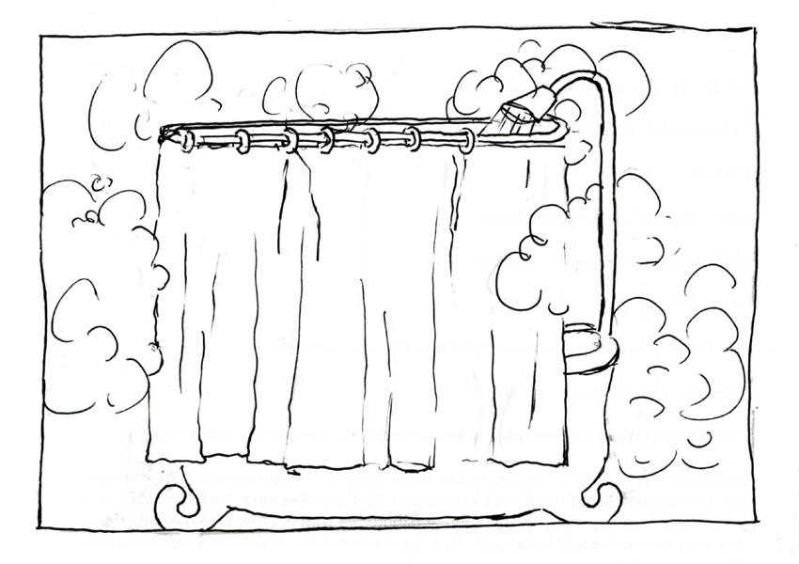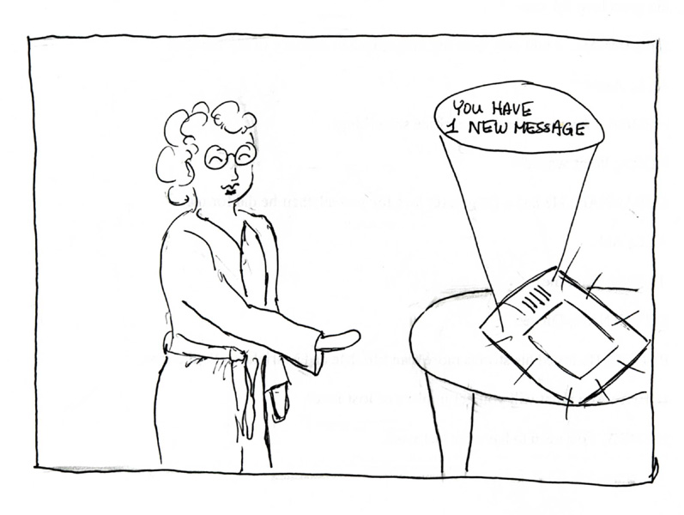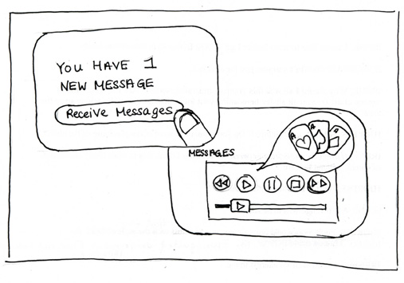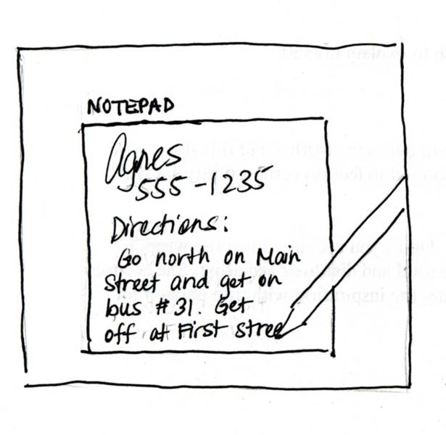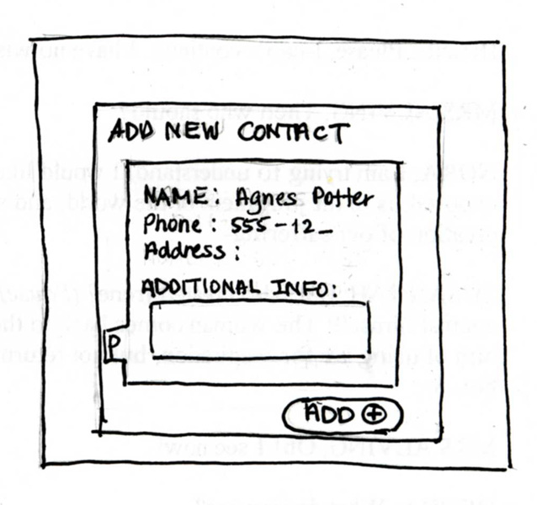

Appendix A-2: Scenario 2
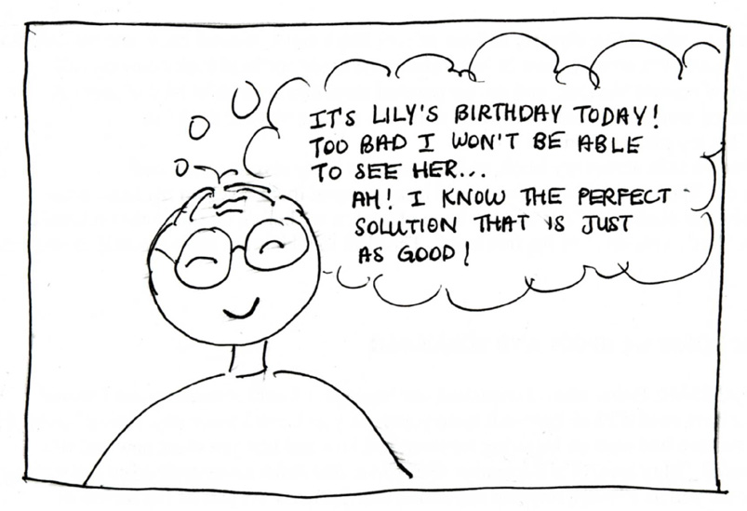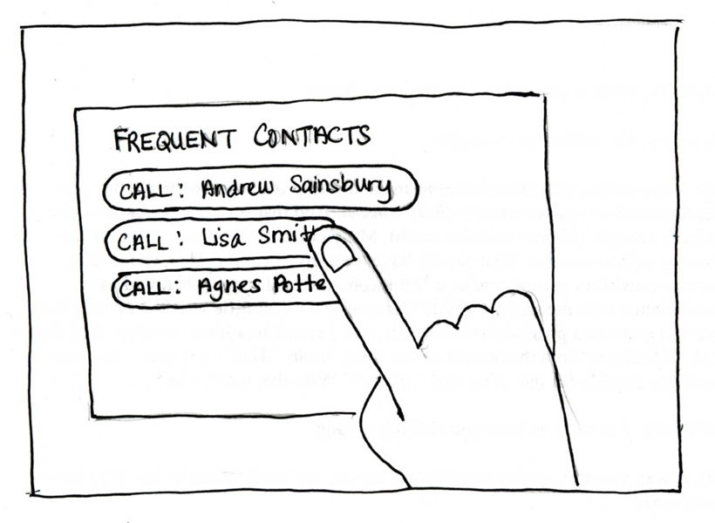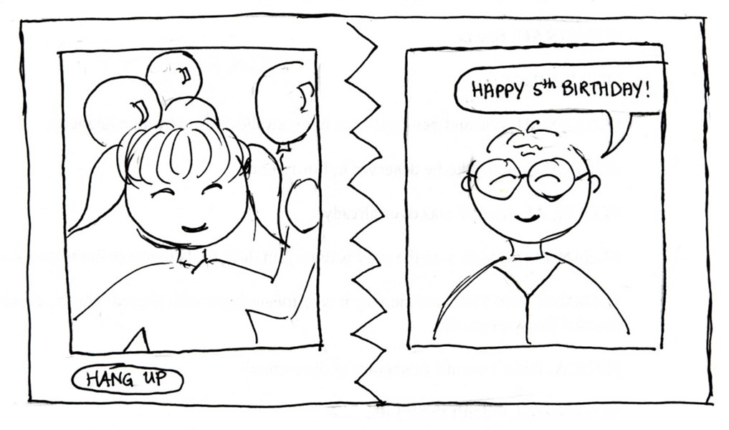

Appendix B: System Flowchart

This diagram details the interactive screen flow hierarchy of the LCD Touch Screen Phone. It also includes a sample of the available functions for each functionality.

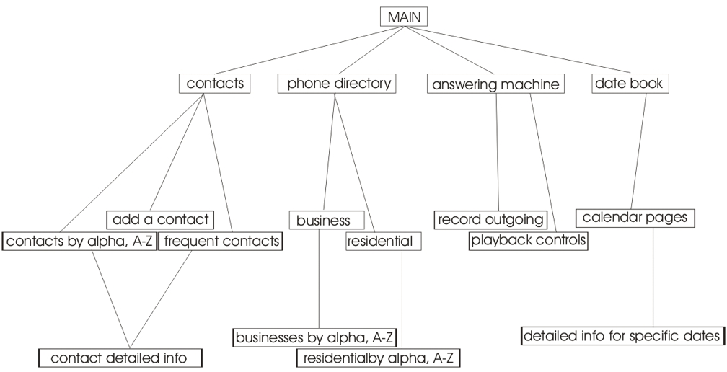
Figure B-1

Appendix C: Interaction Sequence Diagrams

Appendix C-1: Interaction Sequence 1

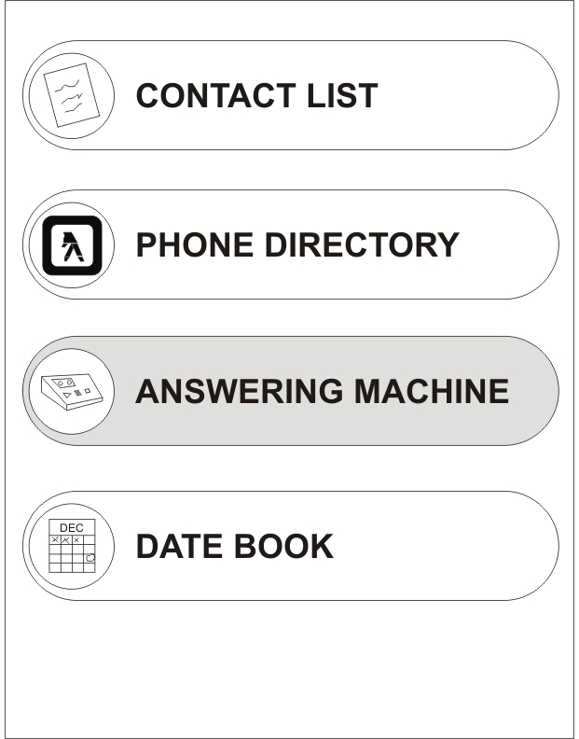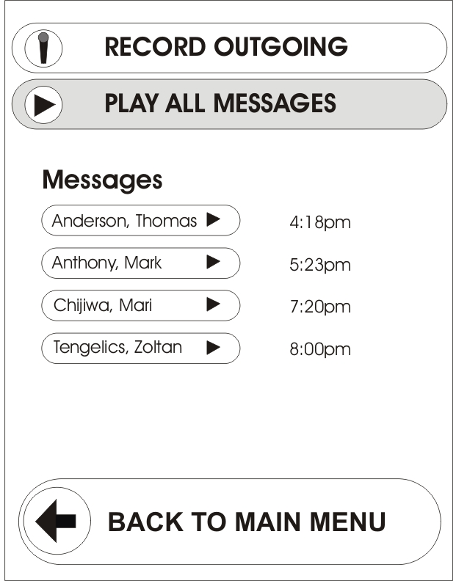
Figure C-1.1 Figure C-1.2

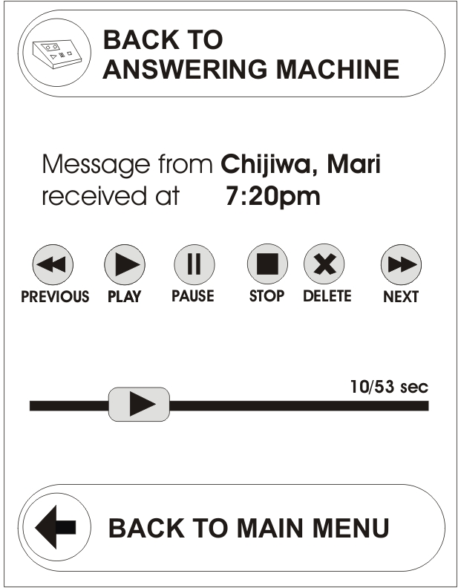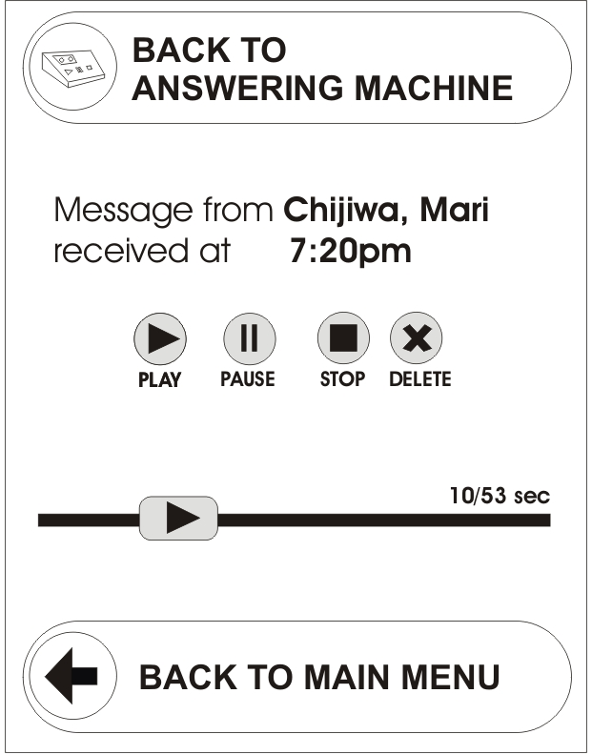
Figure C-1.3 Figure C-1.4

Appendix C-2: Interaction Sequence 2

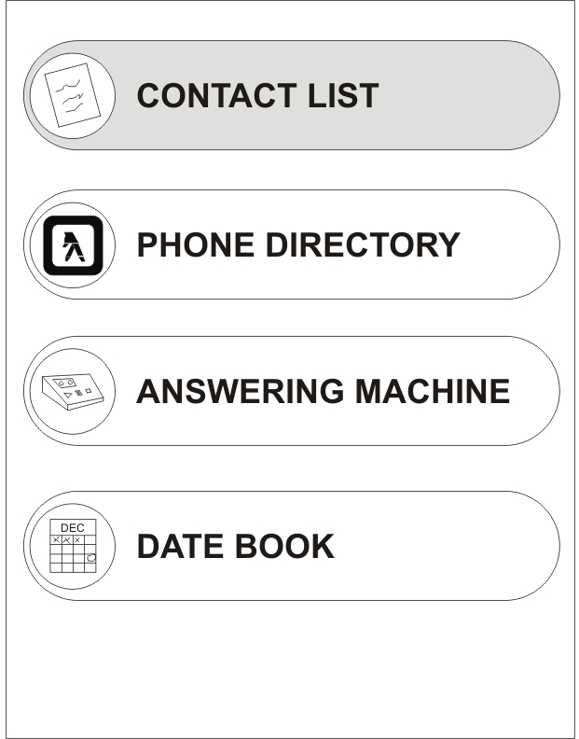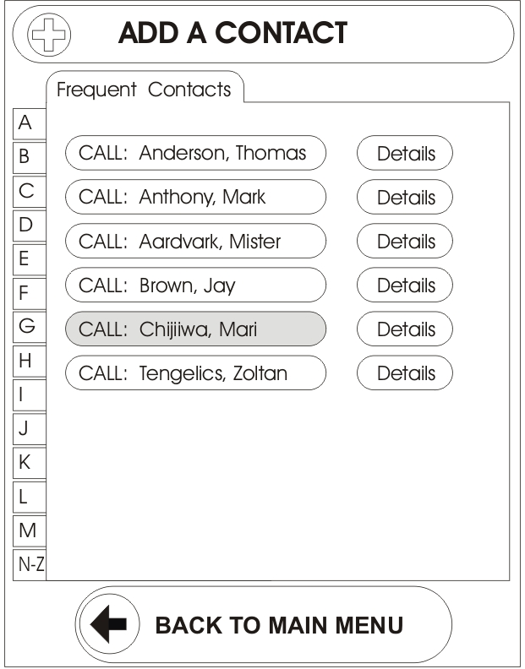
Figure C-2.1 Figure C-2.2

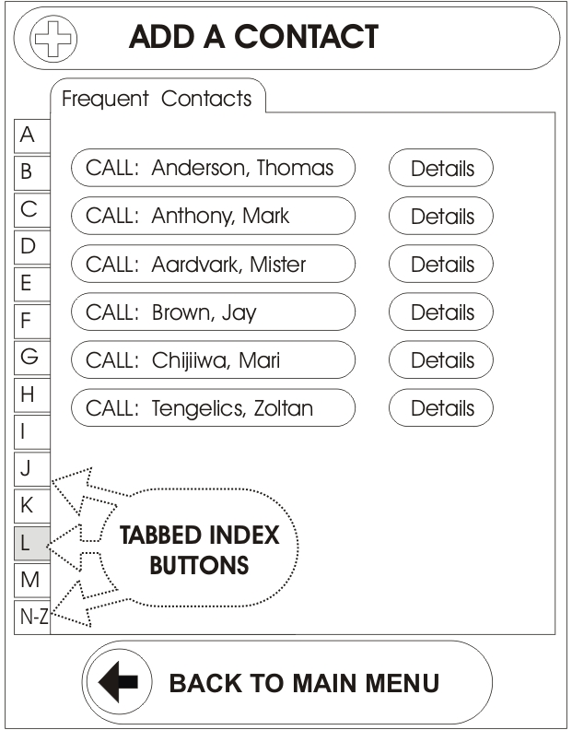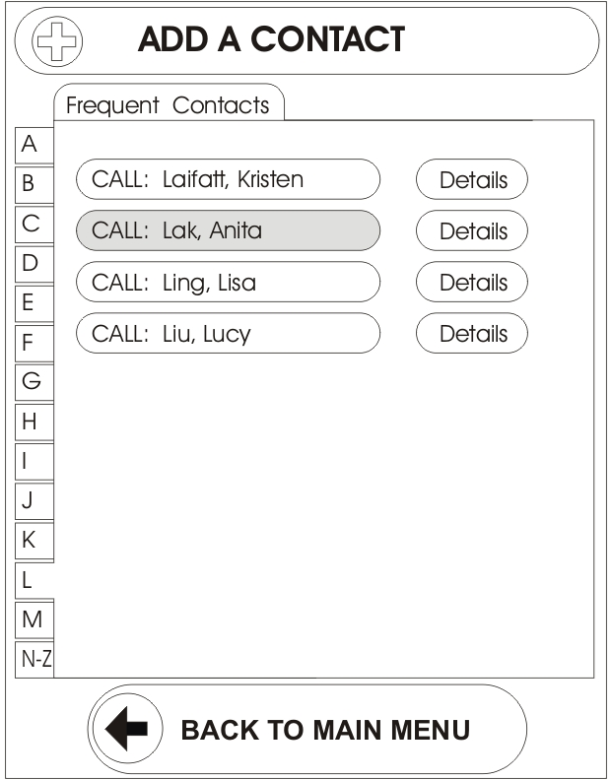
Figure C-2.3 Figure C-2.4
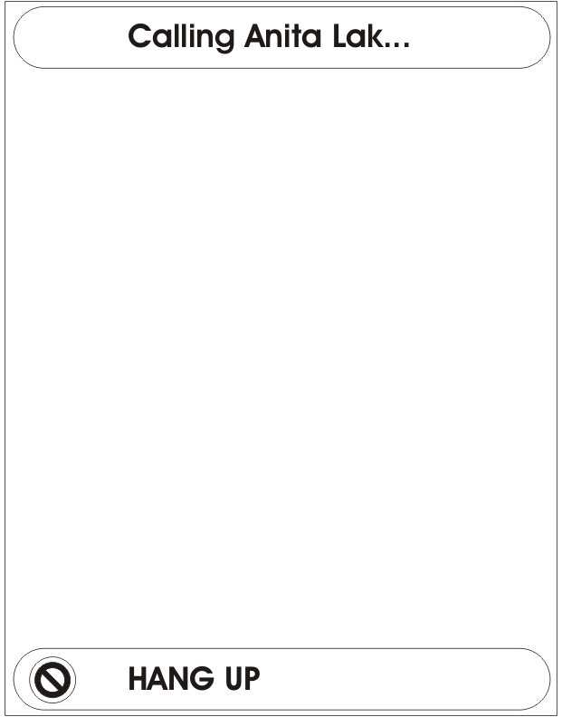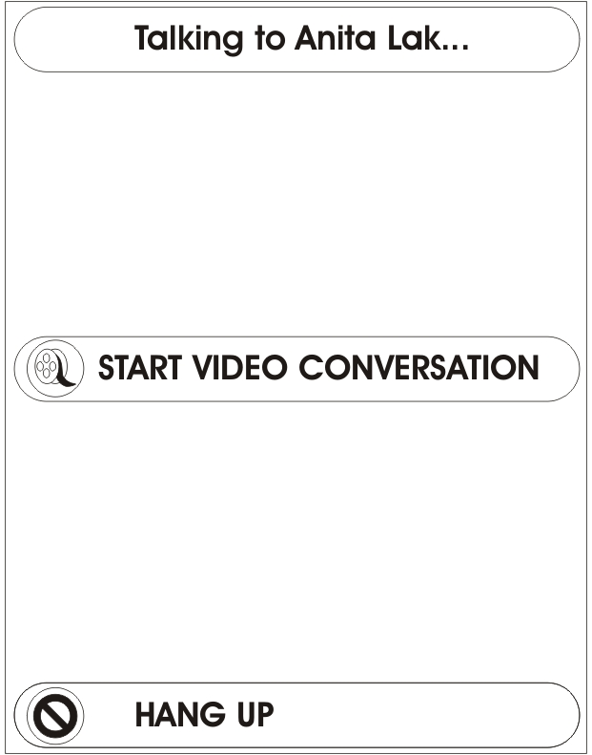
Figure C-2.5 Figure C-2.6

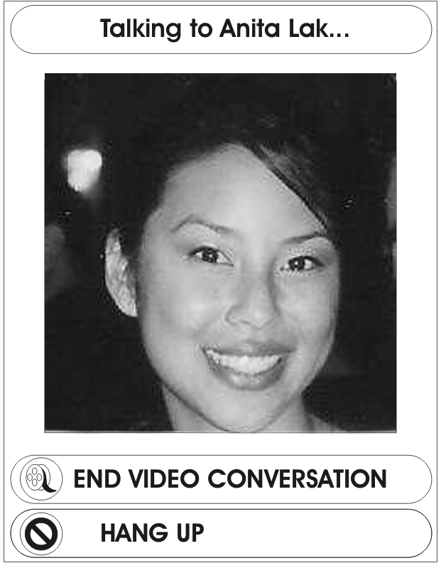
Figure C-2.7

Appendix D: Prototype Design

Appendix D-1: Prototype 1

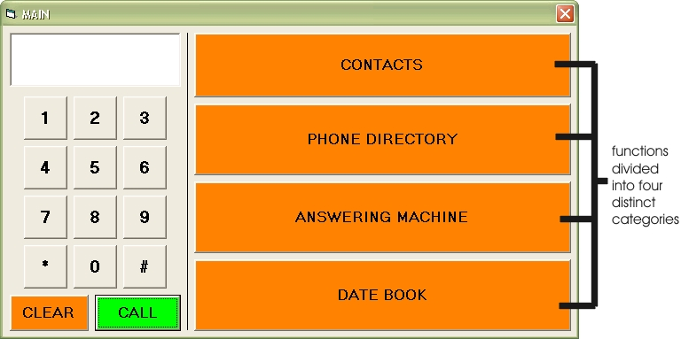
Figure D-1.1

Appendix D-2: Prototype 2

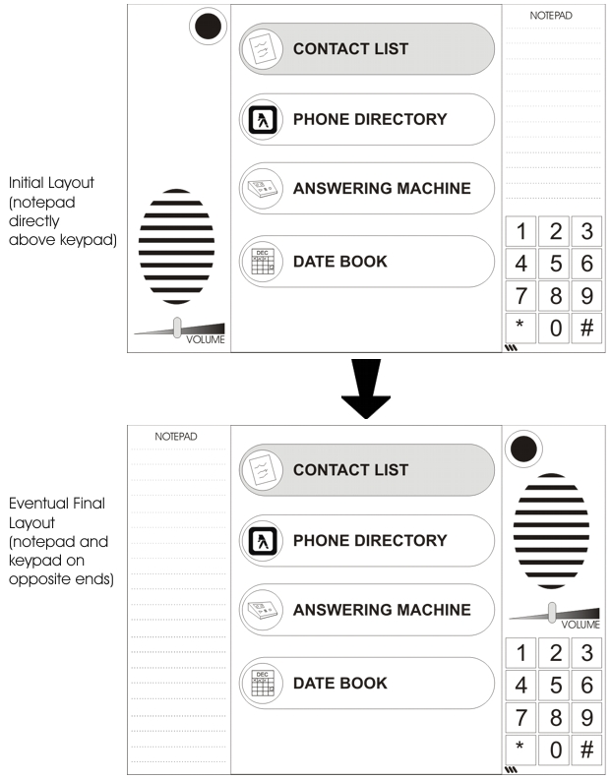
Figure D-2.1
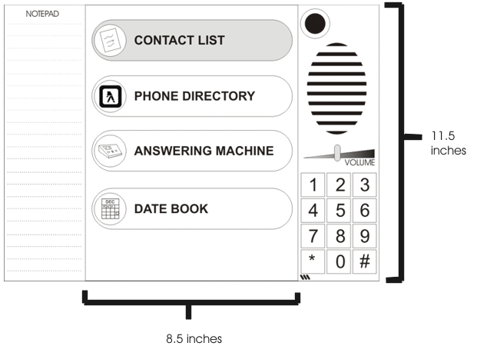

Figure D-2.2

